The PentaPane Class is used to handle a LabVIEW FrontPanel divided into 5 Panes, created using 4 splitters.

The splitters configuration should be first two horizontal splitters and then two vertical splitters in the middle pane

Notes:
- Currently only this configuration of splitters is allowed.
- Splitters can be any width. However splitter width cannot be changed during runtime.
- Currently when using this class panes are not allowed to have scrollbars.
However elements within panes are allowed to have scrollbars.

Public methods:

Init5Panes.vi instantiates an object, extracts all needed data from the caller VI (or other VI Path it receives).
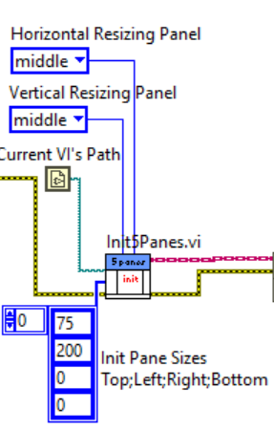

It also configures which pane will be resized when the width or height dimensions of the window are changed and sets the initial size of the panes.

RegisterGUIObjectToResize.vi register an object to be resized when its pane changes size. It receives the reference to the object, the resize behavior to be used:
Adjust – Height, Width or both.
Borders – the space much space to keep around object in pixels or percents of containing panel.
Borders in percent? - if true values of boarders are in percent otherwise in pixels.
Minimal – The minimal size the object may be resized to.
Invisible – If true sets object to invisible and doesn’t resize until object is visible again.
Force aspect ratio – If true graphs are set to keep their axes aspect ratio during resize.
